Snack-Shop Menu

Main Courses
Sandwich | 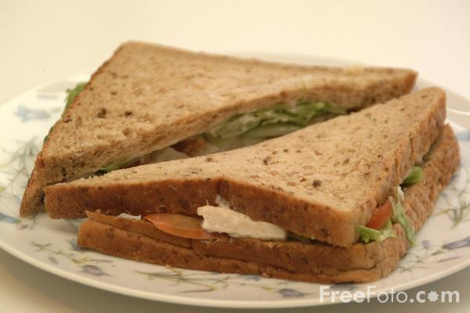 | £ 2.40
Chicken Pie | 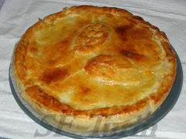 | £ 2.80
Sausages and mash | 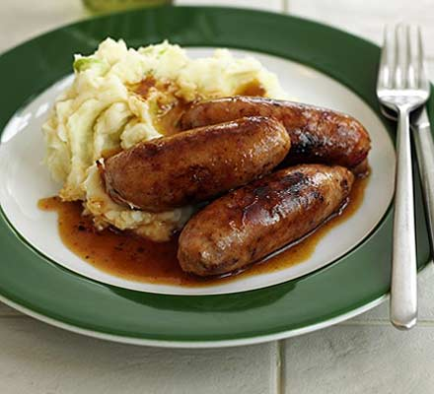 | £ 3.60
Eggs and bacon | 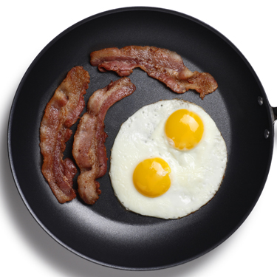 | £ 1.85
Sweets
Waffles and honey | 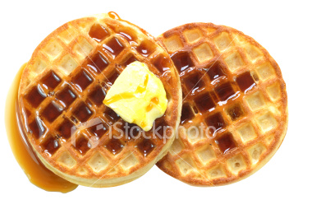 | £ 1.50
Ice cream | 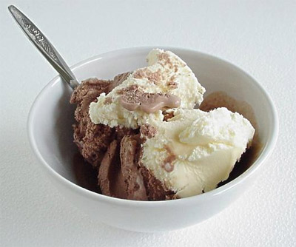 | £ 1.00
Cake | 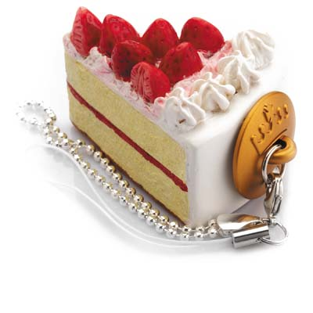 | £ 2.55
Lemon pie | 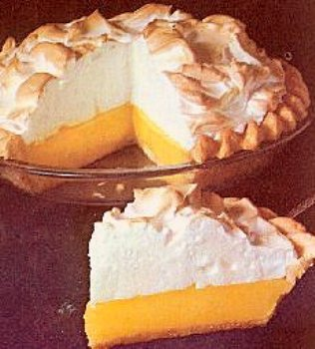 | £ 2.45
Drinks
Lemonade | 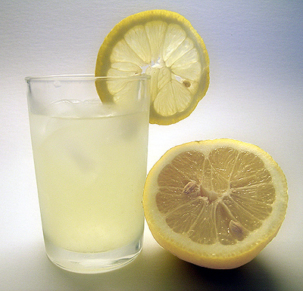 | £ 1.75
Orange juice | 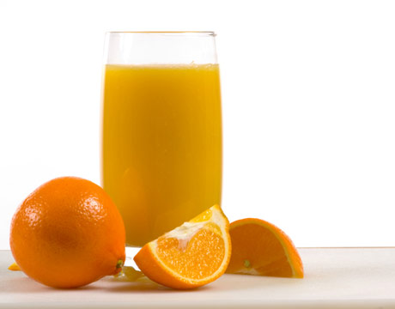 | £ 2.69
Beer | 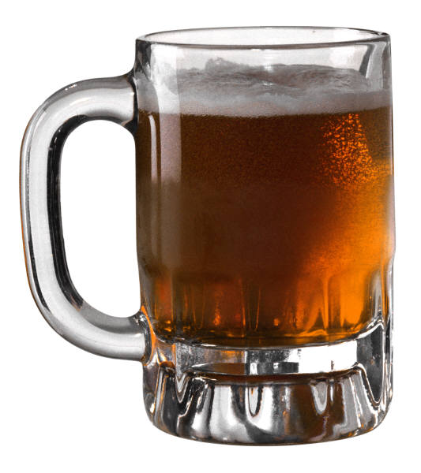 | £ 3.00
Mineral water |  | £ 1.39

Conversation 1

Waiter: Good evening Sir/Madam/Miss.
What would you like?

Customer: I would like ___________________, please.

Waiter: Certainly. Anything to drink?

Customer: _____________, please.

Waiter: Certainly.

........................

Waiter: Here it is.
Enjoy your meal.

Customer: Thank you very much.

Conversation 2

Customer: Excuse me. The bill, please.

Waiter: Certainly. One moment please.
The total is ______________.

Customer: Here it is. Keep the change.

Waiter: Thank you. Come back soon.

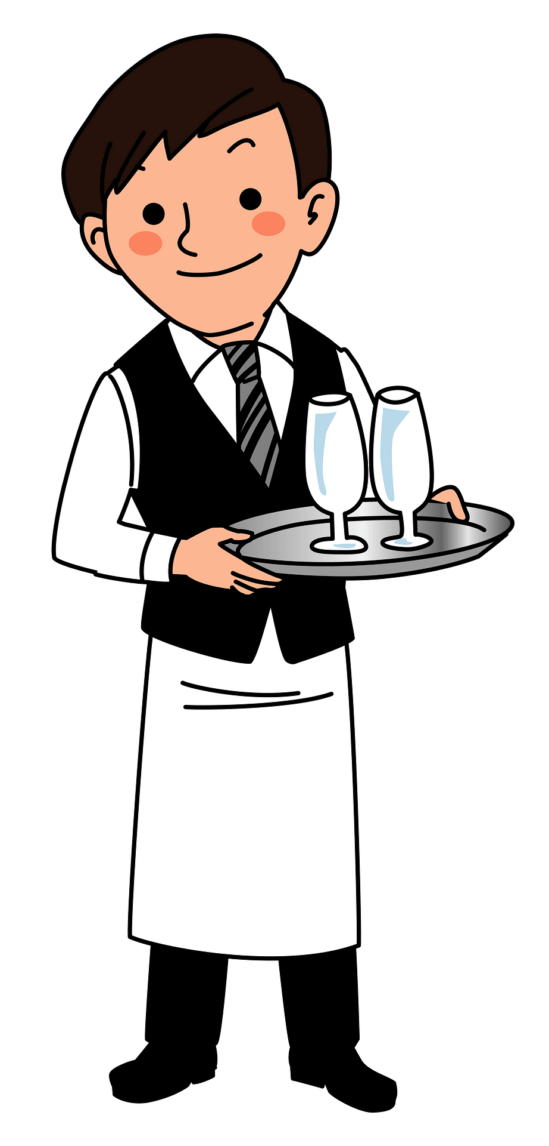


Waiter Waitress

